Pokhara University

Level: Bachelor | Semester – Fall | Year : 2009
Programme: BE |  | Full Marks : 100
Course: Water Resource Engineering II |  | Time : 3hrs.

Candidates are required to give their answers in their own words as far as practicable.
The figures in the margin indicate full marks.

Attempt all the questions.

1. | - What is meant by plant capacity and installed capacity? How will you estimate the installed capacity of hydropower project? Explain.  - Given is the mean monthly flow of a river: |  |  |  |  |  |  |  |  |  |  |  | 7  8
Months |  | Jan | Feb | Mar | Apr | May | Jun | Jul | Aug | Sep | Oct | Nov |  | Dec
Flow,m3/s |  | 100 | 120 | 140 | 300 | 320 | 1800 | 2000 | 2510 | 2000 | 900 | 100 |  | 300
 | Head (H) is 100m, overall efficiency is 90% and if the design discharge is selected to be 900m3/s. Calculate the annual firm and secondary energy
2. | What are the major process to planning of the Hydropower project? |  |  |  |  |  |  |  |  |  |  |  | 15
3. | - Point out the basic criteria that should be considered while selecting dam site as well as reservoir site from technical, geological, and environmental view point  - For a concrete gravity dam as shown in figure below, Calculate the followings:  i) The total vertical forces acting on the dam.  ii) The total horizontal forces acting on the dam.  iii) Factor of safety against sliding.  Take μ = 0.70 and γconcrete = 23.5 KN/m3, γwater = 9.81 KN/m3  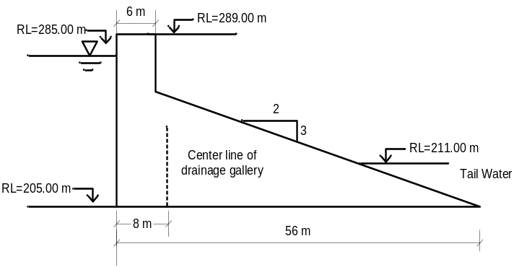 |  |  |  |  |  |  |  |  |  |  |  | 5  10
4. | - What are spillways and what is their necessity? How will you design an ogee spillway?  - A concrete dam has been designed to pass a flood of 3550m3/s in the D/S of the river. The profile of the dam permits a head of 5.25m over the crest. If the discharge coefficient is 0.95 and approach velocity = 0.8m/s, Determine the crest length to safety discharge the above flow. Also if s = 0.001 & n = 0.025 and dam height = 25.0m design the hydraulic jump stilling basin. |  |  |  |  |  |  |  |  |  |  |  | 6  9
5. | - What is a draft tube? Show that the absolute pressure below the runner of a reactive turbine is lesser than the atmospheric pressure.  - A Kaplan turbine developing 3250KW under a head of 6m has a draft tube with inlet diameter 2.8 m and is placed 1.5m above tail water. If the vacuum gauge connected to the draft tube indicates a reading of 5m of water, determine the efficiency of turbine if the efficiency of draft tube is 75%. |  |  |  |  |  |  |  |  |  |  |  | 6  9
6. | - What is meant by economical diameter of penstock? How can it be found out using analytical method?  - Determine the dimension of a settling basin of a hydropower plant based on particle size and concentration approach for the following data:  Q = 25m3/s, Particle to be removed = 0.5mm or coarser, which corresponds a fall velocity of 5cm/s. |  |  |  |  |  |  |  |  |  |  |  | 7  8
7. | - Describe in brief the importance of micro-hydro power in Nepal  - Discuss about the failure modes of embankment dam. |  |  |  |  |  |  |  |  |  |  |  | 5  5

